Greenhouse Gases and Understanding Parts Per Million

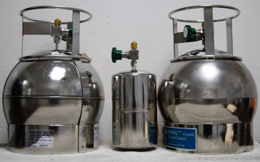

Background:

Greenhouse Gases are certain gases in the atmosphere that act like a "Greenhouse" absorbing heat and warming up the earth. The two most common are CO₂ (Carbon Dioxide) and CH₄ (methane).

When we talk about concentrations of greenhouse gases in the atmosphere, we often use the unit “ppm”. This ppm stand for “parts per million”. We often use this unit when dealing with very small concentrations. Other places you might see this unit used is in air and water quality measurements, where many contaminants are measured in ppm or even ppb (parts per billion).

In this activity you will investigate the concept of parts per million (ppm). A concentration of 1 ppm corresponds to 1 part material per 1 million parts of a gas, liquid or solid medium it is found in (or 1/1,000,000). For example, the current measurement of 400 ppm CO₂ in the atmosphere means that from 1 million parts of the atmosphere, 400 parts are CO₂ (or 400 parts CO₂/1,000,000 parts air)

(Note for reference: When we use the unit %, we are really saying “parts per hundred”, so writing 5% means 5/100)

But just because these amounts are small does not mean that they are unimportant. For example, fish like bass require a dissolved oxygen level of at least 4 ppm. The ambient (normal) air quality standard for the pollutant sulfur dioxide (SO₂) is 30 ppb.

Similarly, greenhouse gases like CO₂ and CH₄ are present in the air in very low concentrations, yet they play a very important role in the earth’s climate.

Today scientists are able to detect some materials at parts per billion or even parts per trillion concentrations. Do you think you cold detect a tiny amount as one part per million?

Comparing Gases in the Atmosphere (“Dry Air”)
Gas | In  Percent (part per hundred) | Conversion by cross-multiplying | In Parts Per Million (ppm)
Nitrogen (N₂) | 78.08 % | $$\frac{78.08 }{100}=\frac{X}{1,000,000}$$
Oxygen (O₂) | 20.95 %
Argon (Ar) | 0.93 %
Carbon Dioxide (CO₂) |  | $$\frac{X }{100}=\frac{401}{1,000,000}$$ | 401
Neon (Ne) |  |  | 18.2
Helium (He) |  |  | 5.24
Methane (CH₄) |  |  | 1.79

Complete the table above. I have given you two that we can do together. The remainder you must find on your own.

