Factors Influencing Solar Insolation Reading

Solar energy that reaches Earth is known as insolation. This word can be thought of as a shortened form of the phrase in coming solar radiation . As sunlight travels deeper into the atmosphere, its speed decreases. This decrease causes the light to bend toward the ground. The bending of light as it moves from one substance to another of different density is known as refraction.

Q: What is refraction: ___________________________________________________________

Solar energy that reaches the ground can be reflected or absorbed. Earth absorbs about half the insolation that reaches the ground, which raises the ground’s temperature. Radiation that is not absorbed is reflected. Reflection is the process by which light bounces off a surface or a material. (Some objects such as clouds have no distinct surface, but they reflect light.) Figure 19-15 below shows how Earth’s atmosphere affects insolation.

Q: Insolation that reaches the ground and is_______ _. This _ __ the temperature of the ground.

Q:

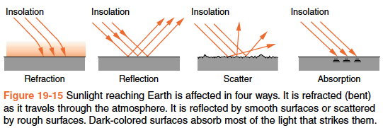

Whether light is reflected or absorbed depends on the properties of the surface it strikes. Dark surfaces absorb more insolation than light-colored surfaces. After all, dark surfaces appear dark because relatively little light bounces off them to reach your eyes. When light reflects off a rough surface, it is reflected in many different directions as shown in Figure 19-15. This is called scatter. Rough surfaces also absorb more insolation than smooth surfaces. This is because rough surfaces have more surface area for light to hit than smooth surfaces,

Questions:
- What absorbs more energy (insolation): Dark colored surfaces or light colored surfaces? Why?

- What absorbs more energy (insolation): Rough surfaces or smooth surfaces? Why?

Probing Question: Which would absorb the least amount of energy?
- A rough colored blacktop
- The choppy waters of the Atlantic ocean
- The snow covered plains of Antarctica
- Smooth covered fields of rocky mountains

Explain your reasoning.

The strength of sunlight depends on the sun’s position in the sky. The angle between Earth’s surface and incoming rays of sunlight is known as the angle of insolation. The angle of insolation is also the angle of the sun above the horizon. If the sun is directly overhead, the angle of insolation is 90°. At sunrise and sunset, when the sun appears along the horizon, the angle of insolation is near 0°. The angle of the sun changes with time of day and with the seasons. When the sun appears highest in the sky, as it is around 12 noon and early in the summer, the strength of sunlight is greatest. There are several reasons for this.

Questions:
- What two times (time of day and year) is insolation greatest:
  - Time of day:__________________

  - Time of year:_____________
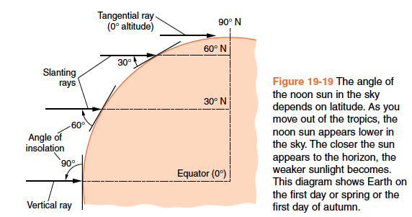

- Look at the figure to the right:
  - What season can this be? Explain.

A given amount of energy confined to a smaller area results in sunlight that is more intense. Figure 19-18 below shows that light is stronger when the source shines straight down on a surface. For any location on Earth’s surface, sunlight is most intense at noon on the first day of summer. You should note that for any location in Connecticut, although the angle of insolation is highest at noon on the first day of summer, even at that time the sun is not directly overhead. Only within tropical latitudes can the angle of insolation be 90°.

The second reason that sunlight is stronger when the sun appears high in the sky is related to absorption of energy by the atmosphere. Earth’s atmosphere is not completely transparent, even to visible light. The lower the sun appears in the sky, the more atmosphere light must pass through to reach Earth’s surface.

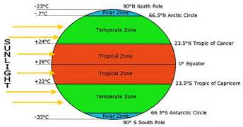
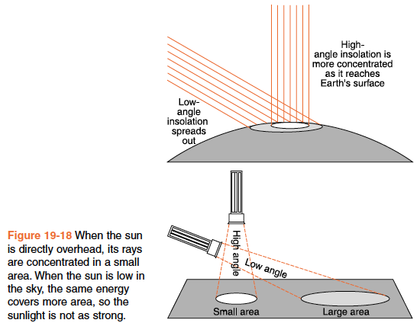
:
Questions:
- The Sun only reaches the zenith/90° within the____________________latitudes.

- A sunny day in winter is colder than a sunny day in summer. Can you explain why?
The final factor is the presence of atmospheric particles. Generally, the more particles (think dust from an asteroid impact or ash from a volcano) or pollutants (think exhaust from a coal-fired power plant) are added to the atmosphere, the lower the intensity of insolation. The reason is because small particles in the atmosphere cause insolation to reflect back out into space – they act like billions of tiny mirrors in the sky that reflect insolation.

Questions:

- Why do particles like ash and dust reduce insolation?

- Would this raise or lower temperatures on the earth’s surface?

- What other naturally occurring materials can you think of that could have this same affect? Name at least 5 potential sources of atmospheric particles.

