Create a Beekeeping Presentation
Your groups goal is to create a presentation that will be shown to the class. You will NOT stand at the front of the room to present! Rather you will create the slides to automatically run.

To do this, create the slides as you normally would. Be sure to use TITLES, SHORT BULLETS and PICTURES to help.

Work together to create the slides. Each person should have a set of tasks. Please create a list of tasks each member of the group is responsible for.

Once the presentation is complete, you can select “Publish to the web...”.
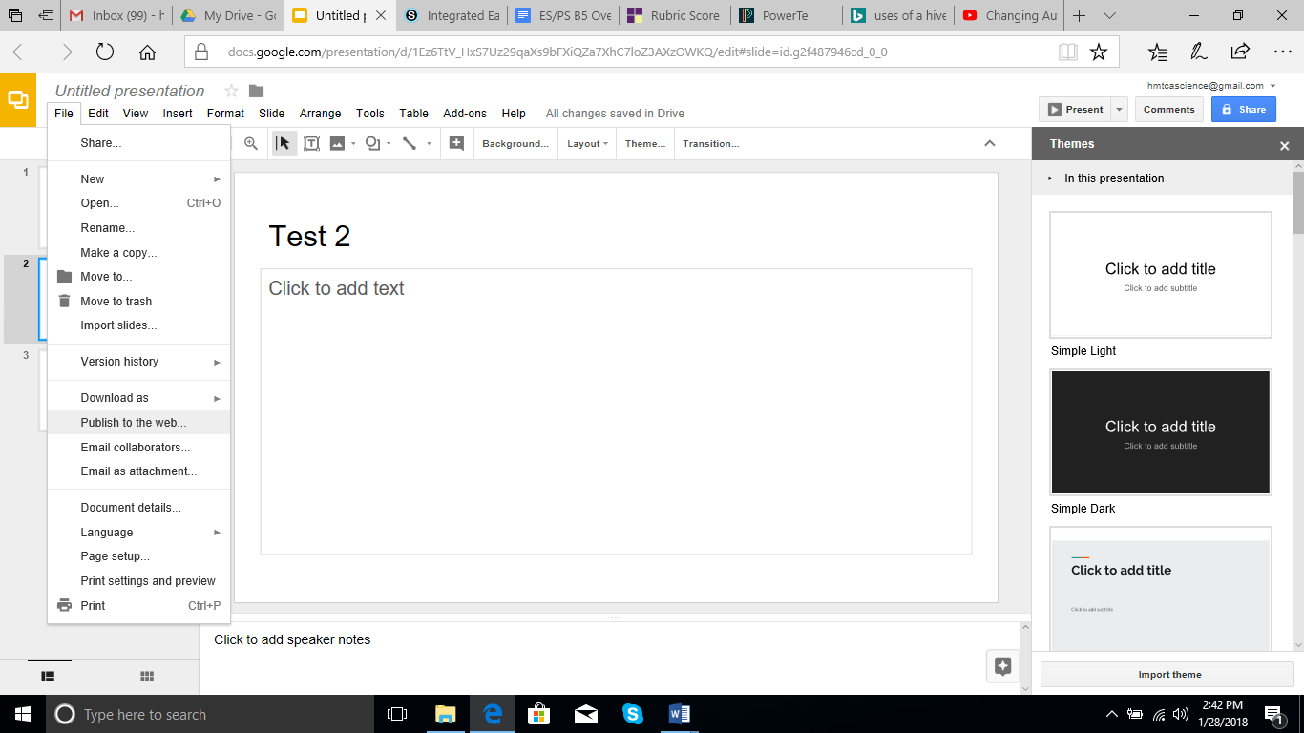

Then change the “Auto Advance Slides” time to 15 seconds (or whatever time you think is best)
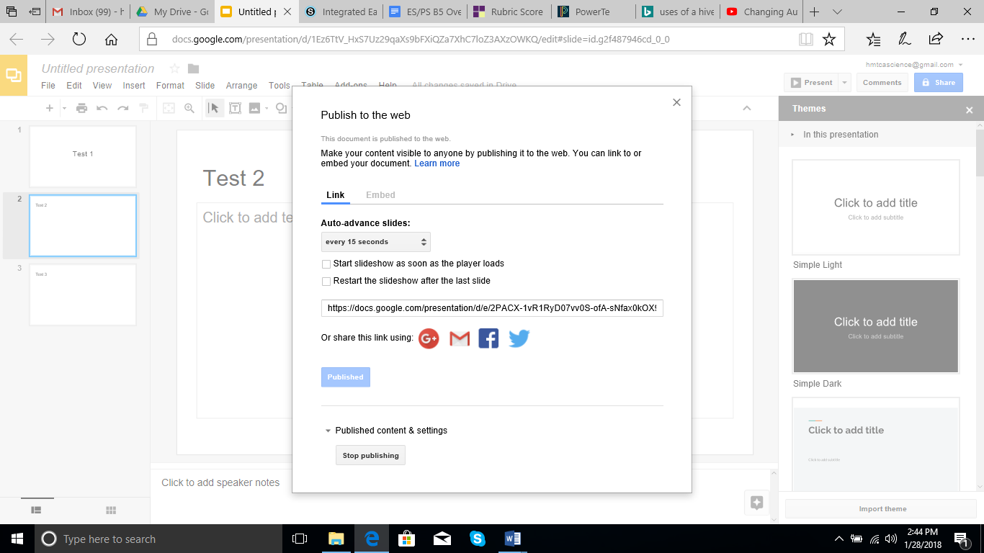

Share the link with me so I can present them to the class. My gmail address is hmtcascience@gmail.com

